Maths problem of the Month (November)

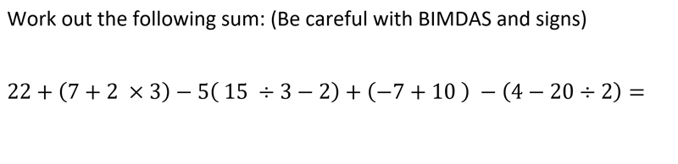
Answers can be submitted via the following link:
https://forms.office.com/Pages/ResponsePage.aspx?id=9cjWPhZMrUSe7WD4UYNKhFs6dIrkdMtOpL182J5WradURDRHU1ZTOUxLUEFLNlpJVE02R0lBV1VSSC4u
Best of Luck.

